AIM: - Introduction to Autocad

THEORY: - AUTOCAD is a software application for computer-aided Drafting (CAD) the software supports both 2D and 3D formats.

PARTS OF AUTOCAD
- 2D
- Advance commands (Productivity tools)
- 3D

- 2D (2 Dimension)
In this section, we come to know how to draw 2D drawing in AUTOCAD.
2D means two-dimensional objects. In 2D we show only two dimensions of an object like:
L X B = Plan
B X H = Elevations/Sections.
L X H = Elevation /Sections.
In 2D three is only 2 co-ordinates x, y because of these co-ordinates we show only 2 dimensions of an object.

Y

X
2D

- Advance commands (Productivity tools)
By using these commands you will create better designs faster .in this section you will learn how to create your own objects library in AutoCAD. Linking of different software with AutoCAD, plotting of your design on different scale. In this section, you also get the knowledge to add parameters to a simple drawing to create parametric drawings. You can use these tools with 2D & 3D both sections of AutoCAD.

- 3D (3 Dimension)
3D means three dimensional, i.e. something that has a width, height and depth. Our physical environment is three-dimensional and we move around in 3D every day. There are three axis in 3D-X, Y, Z

Y

X

Z
3D

LAUNCHING OF AUTOCAD
Launching AutoCAD is very easy. Just double click the Auto CAD shortcut or by start menu.

WORKSPACE OF AUTOCAD
Firstly we discuss about workspaces of Auto CAD:
- Drafting & Annotation
- 3D Basics
- 3D Modeling
- AutoCAD Classic
Auto Cad Interface Elements
- AutoCAD drawing area or view port: This is where you will draw Auto Cad objects.
- AutoCAD Ribbon: This is where you can access AutoCAD tools and settings.
- In each tab have several panels: These Panels have similar AutoCAD tools inside them.
- Command Line: We can activate tools and change the tool settings by typing in the command line. Command line is also providing information on what you should do next.
- Drafting Settings: while we draw, we need to change some drafting settings.

DRAFTING & ANNOTATION
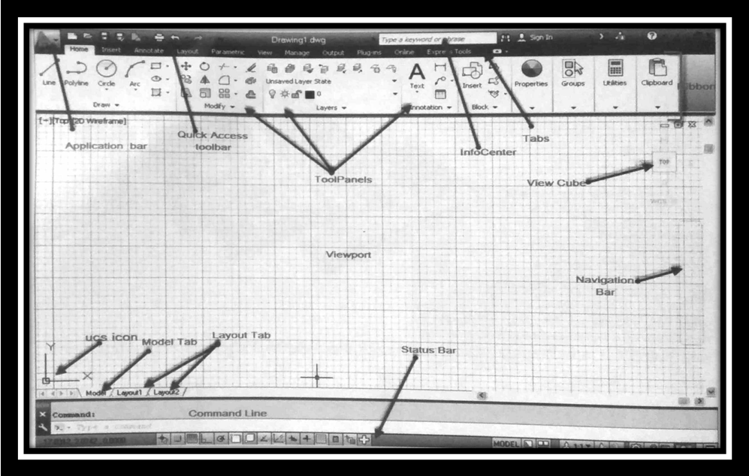

AUTOCAD CLASSIC

